EXPERIMENT 1C

Display the structured, semi-structured and unstructured data

Aim:

To conduct an experiment to differentiate Structured , Un-structured and Semi structured data.

Algorithm:

1. Import the pandas library.
2. Create a **structured dataset** with employee details like ID, Name, Department, and Salary.
3. Convert the structured dataset into a pandas **DataFrame** and display it.
4. Create a list of **unstructured data** items such as files and media.
5. Display each unstructured data item using a loop.
6. Import the json library.
7. Create a list of **semi-structured data** in JSON format containing name, skills, and experience.
8. Display the semi-structured data in formatted JSON style using json.dumps().

Program:

import pandas as pd

structured_data = {

'Employee_ID': [101, 102, 103],

'Name': ['Alice', 'Bob', 'Charlie'],

'Department': ['HR', 'IT', 'Finance'],

'Salary': [50000, 60000, 55000]

}

df_structured = pd.DataFrame(structured_data)

print(df_structured)

unstructured_data = [

"Alice's resume.pdf",

"Meeting recording.mp4",

"image_001.jpg"

]

for item in unstructured_data:

print(item)

import json

semi_structured_data = [

{"name": "Alice", "skills": ["Python", "SQL"], "experience": "2 years"},

{"name": "Bob", "skills": ["Java", "NoSQL"], "experience": "3 years"}

]

print(json.dumps(semi_structured_data, indent=2))

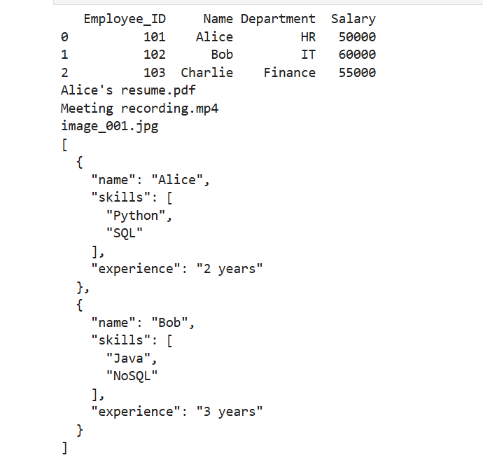Output:

Result:

Hence a program to differentiate structured data, semi-structured and unstructured data is written and executed successfully.